Symmetrize stress data Script - Summary
Purpose
We often export multiphysics results (stress, etc.) only for a partial lens region (half / quadrant) to reduce computation. This Python script generates a full 360° dataset by applying geometric symmetry (mirroring) to the existing sampled points.
What it does
- Reads a .txt dataset containing point data with at least x, y, z columns plus additional result columns.
- User selects symmetry axes (X, Y, Z or combinations like XY/XYZ).
- The script creates mirrored copies using standard reflections:
  - X symmetry: (x, y, z) → (-x, y, z)
  - Y symmetry: (x, y, z) → (x, -y, z)
  - Z symmetry: (x, y, z) → (x, y, -z)
- If multiple axes are selected (e.g., XY), it generates all combinations (original, X-mirror, Y-mirror, XY-mirror), so output points scale by:
  - X → 2×
  - XY → 4×
  - XYZ → 8×
How it handles physics values
- Scalars (stress values, von Mises, temperature, etc.) are kept unchanged during mirroring.
- If the file contains vector components (e.g., Ux, Uy, Uz), the script flips the relevant component consistently:
  - Mirror in X → Ux changes sign
  - Mirror in Y → Uy changes sign
  - Mirror in Z → Uz changes sign
- For headerless exports (no column names), the script asks whether extra columns should be treated as:
  - scalars (safe default for stress exports), or
  - vector triples (Ux,Uy,Uz style data)
Input/output robustness
- Supports files with:
  - comments, blank lines, optional headers
  - comma/tab/space delimiters
- Detects x/y/z from header if present; otherwise assumes first 3 numeric columns are x,y,z.
- Writes one output per file:
  - preserves header/comments
  - preserves delimiter where possible
  - outputs numbers in high precision scientific notation
Key requirement: exact point count multiplication
- The final configuration runs with deduplication disabled by default.
- That ensures the number of rows is exactly:
N × number_of_reflection_combinations
(example: 2379 → 4758 for X symmetry).

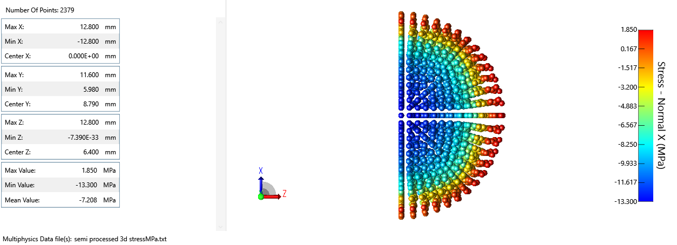
Semi processed 3d Stress data used as input data in python script

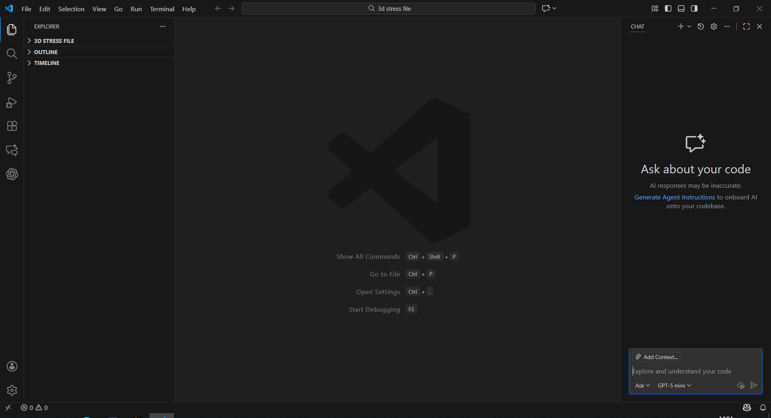
VS Code workspace view showing the project explorer and the integrated Chat panel, ready for running and editing the Python data-processing script.

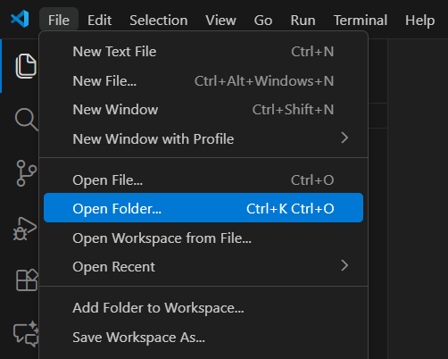  Step 1: In VS Code, open the folder containing the Python script | 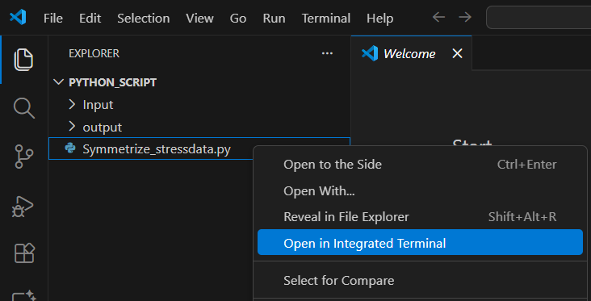  Step 2: Open the Python script in VS Code’s integrated terminal by right-clicking the script file and selecting Open in Integrated Terminal, so you can run it directly from the project folder.

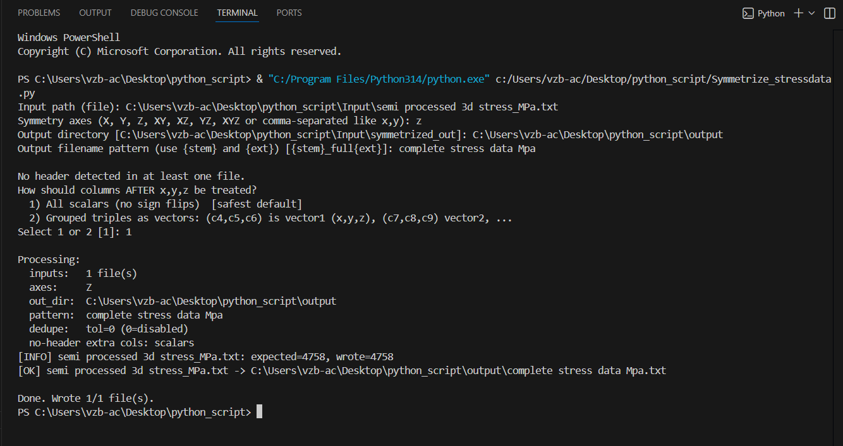

Step 3: Click Run Python File (▶) to start Symmetrize_stressdata.py in the VS Code terminal.
Step 4: When prompted for Input path (file), paste the full path of the input file (semi processed 3d stress_MPa.txt) from the Input folder.
Step 5: For Symmetry axes, enter Z to mirror the dataset across the XY plane and generate the full dataset along the Z direction.
Step 6: For Output directory, paste the full path to your output folder.
Step 7: For Output filename pattern, type the desired output name (e.g., complete stress data Mpa).
Step 8: When asked how columns after x,y,z should be treated, enter 1 (All scalars, no sign flips) since the stress columns are scalar values.
Result: The script generates the symmetric full dataset and saves it in the output folder using the filename you provided (e.g., complete stress data Mpa.txt).

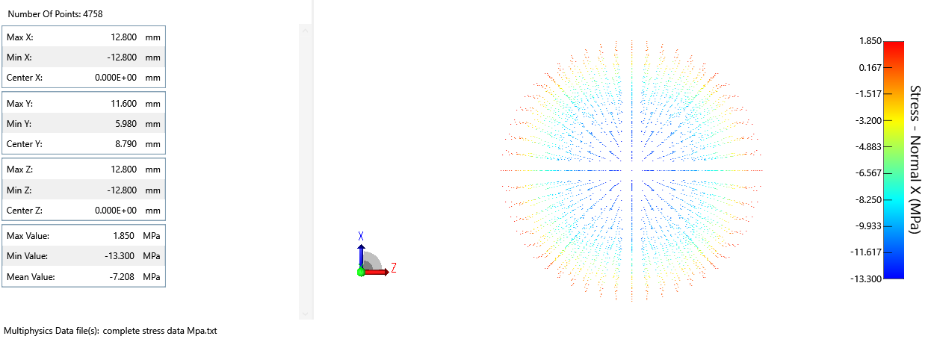
Whole lens Stress file generated by python script with semi stress data

